ES

1. Main Window
   1. Buttons
      1. Add Patient
      2. Diagnose Patient
         1. Name
         2. Age
         3. BMI?
         4. Height
         5. Weight
         6. Gender
         7. Low or high blood pressure
         8. At risk for virus entered for?
         9. Counter measures for them and the MOH
      3. Statistics
         1. Underlying conditions points will tell the severity while the symptoms will tell whether they have covid or not.
         2. Based on the total number of persons entered
            1. At risk or possibly have COVID-19
            2. Percentage with mild symptoms
            3. Percentage with severe symptoms
            4. Percentage with delta variant
            5. Percentage with omicron variant
            6. Percentage with omicron variant that have underlying conditions
   2. Other Info
      1. Underlying conditions (Prolog List Concepts)
         1. Assert
            1. Asserta()
            2. Assertz()
         2. Retract
            1. Retract()
            2. Retractall()
         3. Append
            1. Add a value to a list
            2. Append(list1,list2])
         4. Using recursion
            1. Use recursion to get the list values
         5. Useful functions
            1. Length(List, Variable)
            2. List constructor (|)

Write([albert|[alice,bob]]),nl

* + - * 1. Member (searchval, List)
        2. Append(List1, list2, variable)
        3. Make a list – write_list([])
    1. Details to be accepted
       1. Patient’s temperature in °C to be converted to °F
       2. Experienced dizziness, fainting or blurred vision
       3. If the above is experienced, the systolic and diastolic values (mm Hg) is captured to see if they have low blood pressure
          1. Systolic lower than 90 or diastolic lower than 60
    2. Provide the user with counter measures for long term and short term if the person has COVID
    3. Gives advice to the MOH on possible actions to take and alert the authorities of spikes or increases
    4. Error handling
       1. Inputs – DIAGNOSIS, CONDITION AND ETHNICITY
       2. If ethnicity and underlying conditions query is empty then put (empty) in the dropdown menu.
       3. Make some functions inner functions and get rid of global variables.
       4. Add a pop up for when they submit successfully.
       5. Make sure that the person’s name is capital
       6. Empty fields
       7. Ask underlying condition then display them as checkboxes
       8. When something is added, remove (empty).
       9. Take out virusstats from knowledge base and add it when the stats are calculated in the addpatients.
       10. # TODO: DESTROY THE WINDOW WHEN A PATIENT, CONDITION OR ETHNICITY IS SUBMITTED
       11. TODO:Get the conditions and the symptoms
       12. 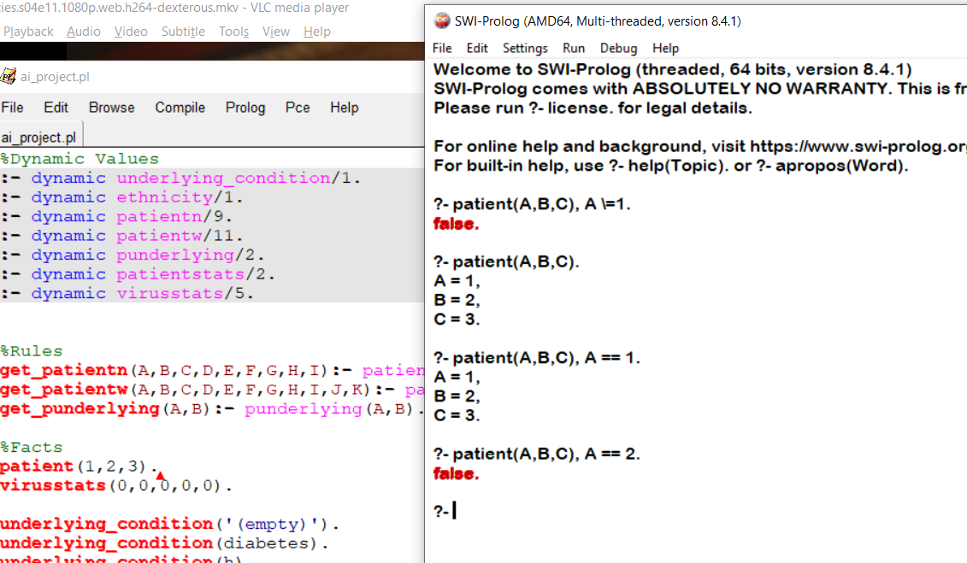
       13. Put a fact about obese and hyper and hypo blood pressure
       14. Destroy a frame when another one is called???

COUNTRY???????????????????

Name

Age

Ethnicity

Temperature in Celsius

Experience dizziness, fainting or blurry vision

Systolic and Diastolic Pressure

Also add other symptoms that need to be checked using the systolic and diastolic pressure

Height (Ft)

Height (In)

Weight

Gender

Underlying Condition:

Chronic Lung Disease (Asthma, Cystic Fibrosis)

Serious Heart Conditions

Obesity (To be calc)

Diabetes

Chronic Kidney Disease

Chronic Liver Disease

Blood Disorders (Sickle Cell, Leukemia)

Pregnant

Smoke

High Blood PRESSURE

Dementia

Resources

<https://www.youtube.com/watch?v=SykxWpFwMGs&ab_channel=DerekBanas>

1. 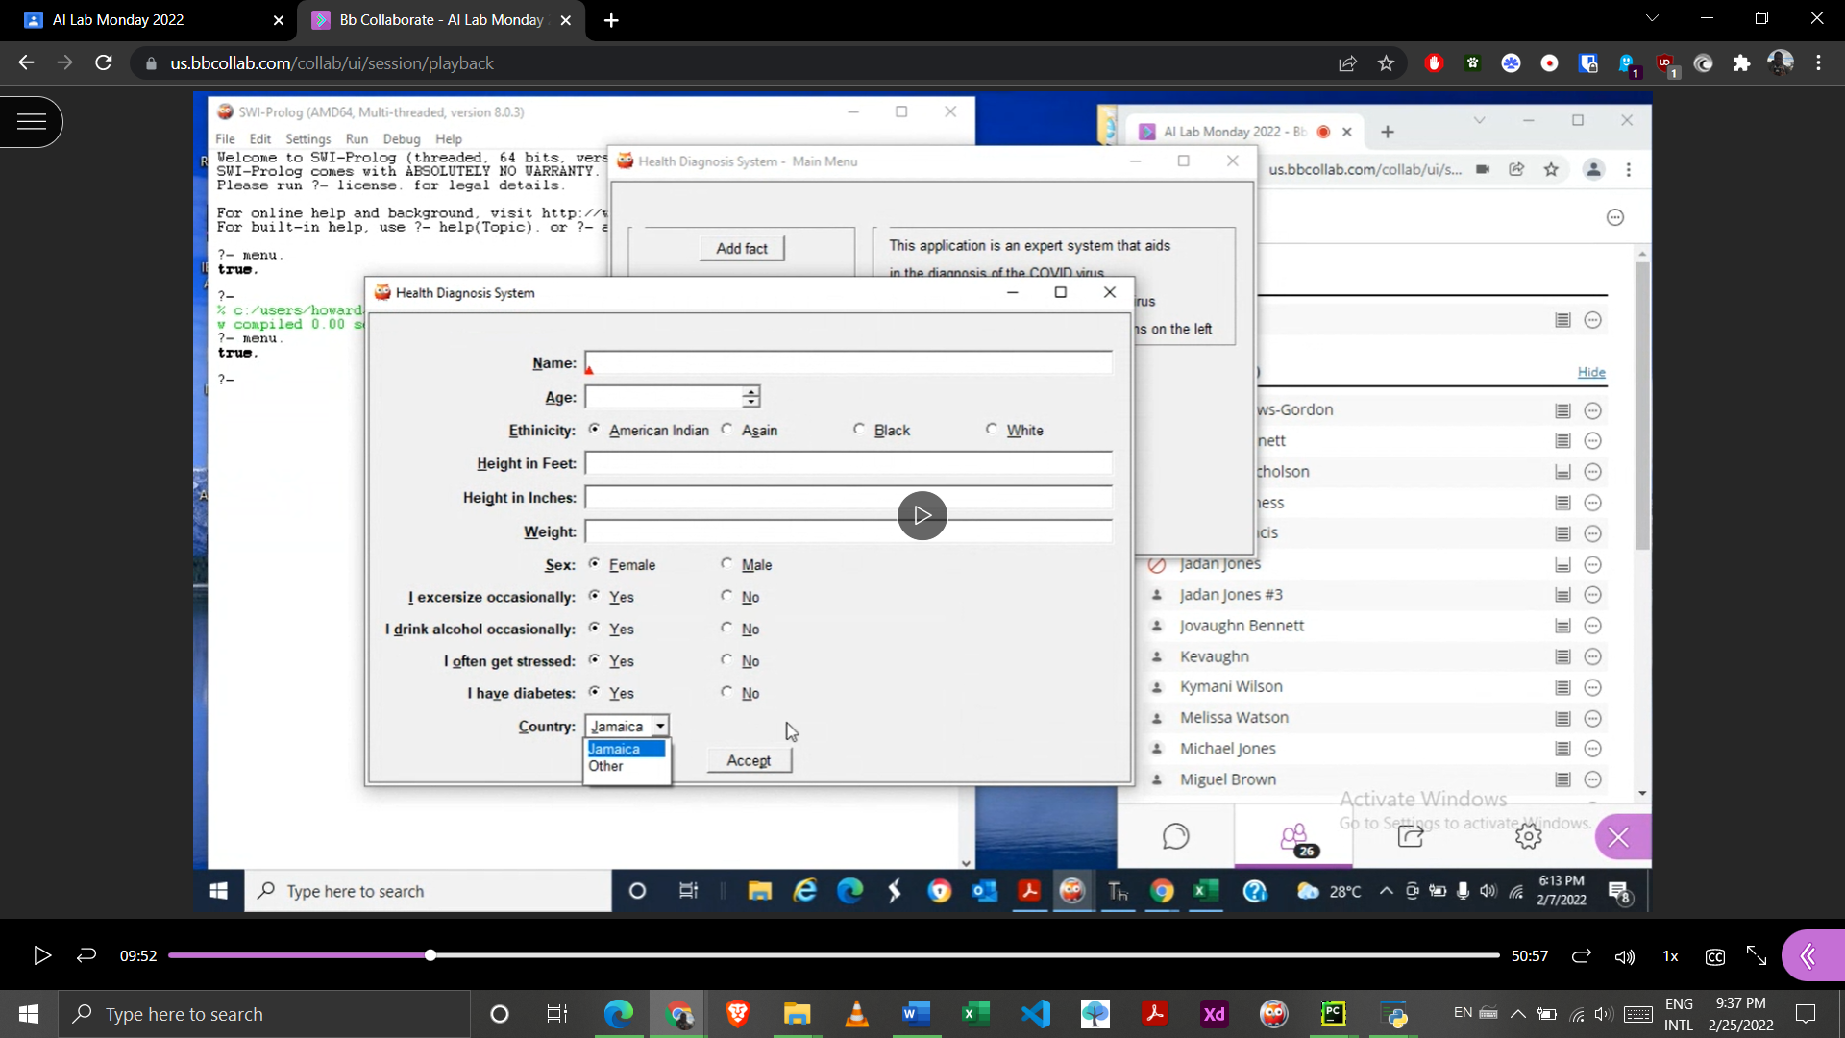
2. 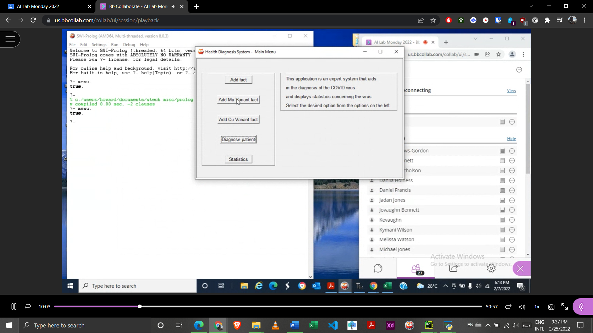
3. 